CASE STUDY
What impact, if any, do informal activities/conversations between Seminary teachers and students have on the religious observance and/or identification of their graduates, and are some activities more impactful than others?’
Introduction
Over the past three decades the “Year in Israel” has developed into a form of post-high-school rite of passage for the Orthodox young man or woman living outside of Israel, with thousands of young men and women travelling each year from the United Kingdom, Canada, France, Australia, South Africa and North America to engage in some form of study or experiential programme in Israel.
In terms of religious study, the primary reason for spending a “Year in Israel” is to attend Yeshiva or Seminary which is considered by many to be “the culmination of a Modern Orthodox day school education” (Tobin, 2003, p. 382). This perspective is further compounded by the fact that numerous Jewish high schools have an assigned Israel guidance counsellor (Eisenberg, 2010, p. 3) and in the case of the UK, numerous schools conduct a week-long visit to Israel in Year 12/13 to visit prospective Yeshivot or Seminaries. As Steve Eisenberg remarks, “the year in Israel has become a formalized part of the American Jewish educational experience” (Eisenberg, 2010, p. 3).
But while the most observable reason for Yeshiva and Seminary study is in order to learn Torah, (Unterman, 2003, p. 161), this term “conceals a broad range of goals, one of which is the socialization, ie. moulding the student in accordance with a desired social model” (Unterman, 2003, p. 161). As Shalom Berger explains in his ground-breaking study on ‘The impact of Post-High School Study in Israel’,
“Students, away from their parents for an extended period for the first time, assume the values of the yeshiva. Do they become more knowledgeable about their Jewish heritage? Do they become more committed to Jewish law and Jewish learning? Do they affirm their commitment to building a Jewish family, and begin to consider the possibility that its place will be in Israel? Do they come to see themselves as critical to the future of the Jewish people? The answer to all of these questions is an emphatic “yes!”” (Berger, Jacobson and Waxman, 2007, pp. 73-74).
However, despite the importance of Berger’s conclusions, a noted criticism by both Brizel (2007) and Schachter (2009) is that Berger’s primary focus is the male yeshiva experience rather than the female Seminary experience.
More recently, a longitudinal study by the Azrieli Graduate School of Jewish Education led by David Pelcovitz & Steve Eisenberg looked more broadly at the impact of the year of study in Israel, with its 2010 interim report stating that those who attended Yeshiva or Seminary “exhibited significant increases in nearly all measured areas of religiosity including learn, prayer, belief in G-d, Shabbat, modesty, and kashrut” (Yeshiva University, 2010), adding that “overall, young women reported higher religiosity scores than young men” (Yeshiva University, 2010).
As a teacher at two Seminaries, I am very interested in the process of religious change that takes place amongst students, and in particular, in the factors that contribute to and foster such changes.
In his important study on ‘Psychological Perspectives on Change during the “Year in Israel”’, Daniel Jacobson identifies a number of factors contributing to religious change, noting that “although students change in many different ways, spiritual moments are almost universally directly or indirectly important in the process” (Berger, Jacobson and Waxman, 2007, p. 96). These moments were described by one student as “Kodak moments, defining moments” (Berger, Jacobson and Waxman, 2007, p. 99), and according to Jacobson, “most students report a conversation as the turning point of their year” (Berger, Jacobson and Waxman, 2007, p. 98). However, paralleling Brizel and Schachter’s critique of Berger’s study, Steven Eisenberg has pointed out that Jacobson’s study was limited to a sample of 18 respondents, all of whom were men (Eisenberg, 2010 pp. 9-10).
This omission led Eisenberg to undertake his fascinating study on ‘Spiritual and Religious Mentoring – The role of Rabbis and Teachers as social supporters amongst Jewish Modern Orthodox High School graduates spending a year of study in Israel’ for which he surveyed 598 people, of whom 319 were female graduates of Seminaries, and 279 male graduates of Yeshivot. However, instead of measuring the religious changes made by these graduates, Eisenberg focussed on the role of rabbis and teachers as spiritual and religious mentors to support, and possibly inspire, such change. As he explained, “teachers… should recognize the important role that social support plays in the overall religious development of their students” (Eisenberg, 2010, p. 81), suggesting that “teachers may invite the students to go on a walk, a hike, or even to cook together on a Thursday night” (Eisenberg, 2010, p. 81), adding that “the long-term impact that these seemingly mundane activities have should not be underestimated” (Eisenberg, 2010, p. 81).
As a Seminary teacher I was curious to learn more about the phenomenon of religious change in such settings, and in particular, I believe that Eisenberg’s remarks regarding the impact of ‘seemingly mundane activities’ deserve further exploration. As Yin explains, a case study “investigates a contemporary phenomenon in depth within its real-life context, especially when the boundaries between phenomenon and context are not clearly evident” (Yin, 2009, p. 18), and in this instance, the relationship between the phenomenon of religious change amongst Seminary students and the real-life context wherein these changes occur is not fully evident.
The Aim of the Study
Given the above, the aim of this case study is to investigate the impact of informal student-teacher relationships in Seminaries in relation to religious change, and in particular, the role that the Seminary environment - along with other informal activities have on the religious observance or identification of Seminary students. Specifically, I am interested in answering the question of ‘What impact, if any, do informal activities/conversations between Seminary teachers and students have on the religious observance and/or identification of their graduates, and are some activities more impactful than others?’.
Propositions
While discussing the role of theory in design work, Robert Yin writes that “theory development as part of the design phase is essential, whether the ensuing case study’s purpose is to develop or test theory” (Yin, 2009, p. 35), and as Sutton and Staw explain, this requires that a researcher proposes “a [hypothetical] story about why acts, events, structure and thoughts occur” (Sutton and Staw, 1995, cited in Yin, 2009 p.36). Therefore, basing myself on the literature cited above as well as my own experiences, my three primary propositions were that:
- Activities and conversations outside the classroom are more significant contributors to the religious growth of Seminary students than the learning and discussion which takes place inside the classroom.
- Of all outside- the-classroom activities, informal conversations with teachers are the most significant factor that contributes to the religious change of Seminary students.
- In keeping with Jacobson’s study which focusses solely on the male yeshiva experience, Seminary students who undergo religious change might be able to identify a specific conversation as the turning point for their religious growth.
Methods
Given that this case study is investigative, I adopted a “Mixed Methods Design” (Yin, 2009, p. 62) in which I conducted a quantitative survey of graduates of a specific Seminary where I teach, after which I conducted focused interviews (Yin, 2009, p. 107) with a sample of respondents to the survey in order to develop a better understanding of the responses that they provided.
It is noteworthy that my study is limited to graduates of a single Seminary, as compared to the previous studies mentioned in the Introduction. However, aside for reasons of time, the reason for doing so was deliberate, since a number of my propositions relate to activities that occur outside the classroom. By focussing on the graduates of a single institution (which itself is based within a larger campus), the respondents could provide more detailed responses to their experiences both inside and outside the classroom, and these responses, employing a shared physical language, could then be compared with one another. This means that this case study was, in practice, a multiple case design in a single setting (Yin, 2009, p. 62).
Survey
Basing myself on the previously cited literature I produced a quantitative survey of 10 questions which was sent to graduates of the Seminary from 2013 onwards (see Appendix I for the link to the survey). However, while the data that I sought from the survey was primarily quantitative, each question included a response of ‘other’ to which respondents could provide an alternative answer to the options available in the survey. In accordance with the Middlesex University Ethics Framework (Middlesex University Ethics Committee, 2014, p. 1), all respondents were given the option of providing anonymous responses, while those who were willing to participate in a further focused interview were invited to submit their personal details.

Focused Interviews
Having received responses from the survey, I then conducted focused interviews with a sample of respondents who had provided their personal details, and in accordance with the Middlesex University Ethics Framework (Middlesex University Ethics Committee, 2014, p. 1) all interviews were conducted with consideration of ethical practice, with participants being asked to provide written consent prior to participating in the interview. Moreover, given my personal involvement in this Seminary and in order to maintain integrity and avoid bias, participants were requested that they not refer to any activities or conversations that took place between ourselves and also to avoid – where possible – mention of specific names of other teachers.
Results
In response to the survey, 32 graduates responded. Below are the responses to each of these questions, along with brief summaries relating to each response.
Question 1: Do you think that you experienced any religious change during your year in Israel?
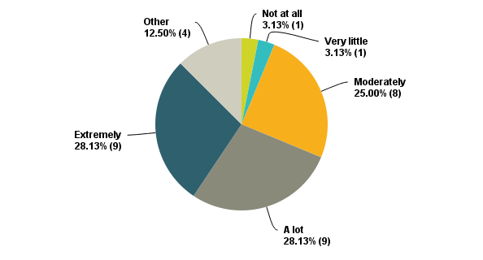
The responses to Question 1 indicate that a majority of respondents felt that they underwent religious change during their year in Israel. Of those who selected the ‘other’ category, the majority recorded broadly positive remarks such as the responded who noted that ‘I remained the same observant level, but I am now much more spiritually connected’, while just one respondent recorded that she experienced a negative change.

Question 2: If you did experience any religious change, to what extent do you think this can be attributed to what you learnt in class from your teachers?
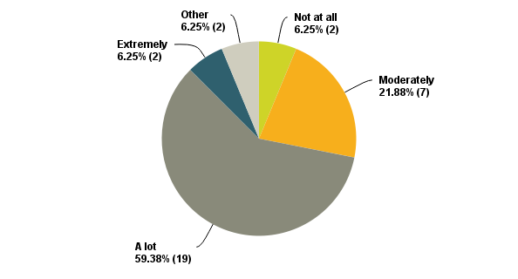
The responses to Question 2 clearly show how a great majority of graduates attributed their religious change to what was learnt in class. However, it is noteworthy that just 2 respondents selected the ‘extremely’ option, while 19 chose the ‘a lot’ option. This may suggest that while classes are very important for the process of religious change in Seminary, they alone may not be the primary transformative factors. Of those who selected the ‘other’ category, most were generally positive such as the respondent who remarked that ‘I remained the same observant level, but I am now much more spiritually connected’, while one respondent recorded that she experienced a negative change.
Question 3: If you did experience any religious change, to what extent do you think this can be attributed to what you learnt in non-class settings from your teachers?
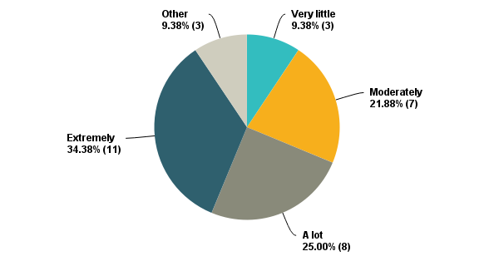
The responses to Question 3 suggest that a large number of respondents attribute their religious change to learning outside of the classroom. While only 2 people selected the ‘extremely’ option to Question 2, 11 respondents did so here, and it is noteworthy that no student selected ‘not at all’ in their response here. Of the 3 who chose the ‘other’ category, all were broadly positive such as the respondent who remarked that ‘just being in Israel makes you much more proud due to all it represents and the Jewish pride there’.

Question 4: When considering your time in Seminary, to what extent was it beneficial that you were able to talk to teachers in an informal setting?
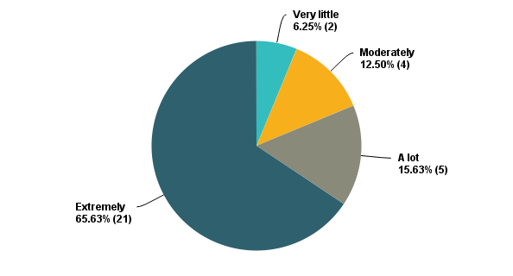
It is very clear from the responses to Question 4 that the great majority of students found it beneficial to talk to teachers in an informal setting.
Question 5: In your own opinion, how valuable was it for you to be able to eat a meal with a teacher in the dining room and talk with them?
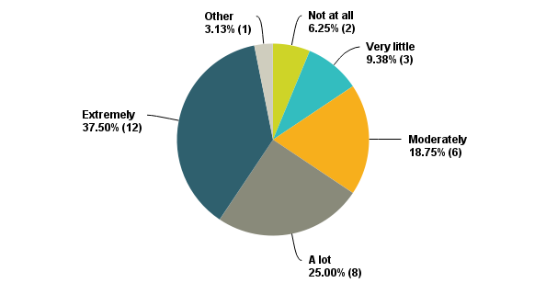
The responses to Question 5 indicate that many students appreciate the ability to eat and talk with a teacher in the dining room. The single student who selected ‘other’ wrote that she ‘didn't really get the opportunity’. This is surprising and raises the question of whether all students have equal access to teachers during their non-teaching time, or how teachers communicate their availability to speak with students in such settings.

Question 6: In your own opinion, how valuable was it for you to be able to sit/walk with a teacher around the campus and talk with them?
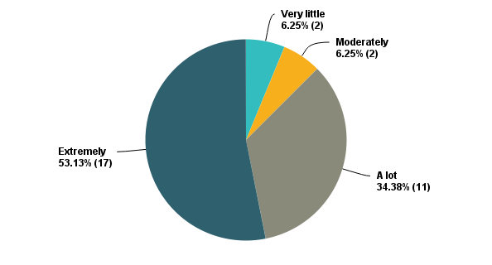
The responses to Question 6 indicate that the great majority of students valued the ability to sit or walk with a teacher around the campus and talk with them. This high response points to the significant role of a campus as providing a suitable space for student-teacher conversations.
Question 7: Was there any other informal activity that you did with a teacher (eg. Cooking with them) or that a teacher did with you (eg. Helping you with something) which you think was important to your religious development during your year in Israel? If so, please provide details.
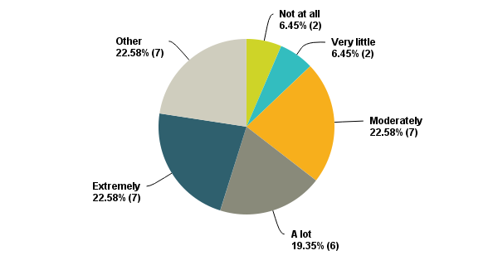
The responses to Question 7 were mixed, and numerous respondents chose the ‘other’ category, although the reasons for doing so were primarily to provide further details regarding the informal activity such as the student who described how she ‘was working with Mrs X in a chavruta on understanding Psychology and the presence of Hashem in Torah and in our everyday lives’. However, one respondent – who previously responded to Question 5 that they didn’t get the opportunity to eat with a teacher in the dining room - wrote that such opportunities ‘Didn't happen’.

Question 8: In your own opinion, how valuable was it for you to be able to visit a teacher’s home for a Shabbat or Festival?
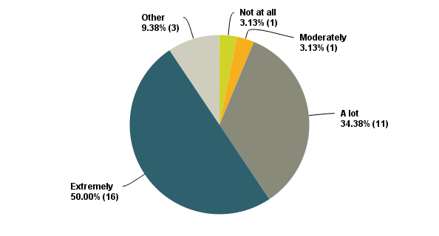
The responses to Question 8 show how the vast majority of students value spending time at the home of their teacher for Shabbat or Festivals. Of the 3 respondents who selected the ‘other’ category, all were positive such as the respondent who remarked that ‘when you visited a teacher you saw how they spent shabbos with their families which helped develop how I want my shabbos table to look like’.
Q9: Were there conversations that you had with your teachers which you considered, or consider, to have been turning points in your religious observance or identification?
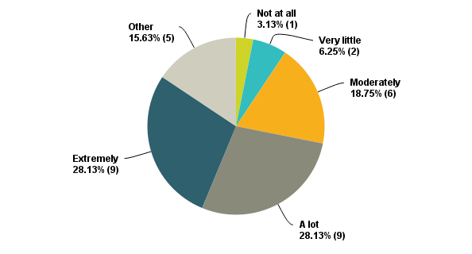
While the responses to Question 9 clearly indicate that numerous students had turning-point conversations with their teachers, a contrast between these responses and those to Questions 4 & 6 indicate that while respondents placed great importance on talking with teachers in informal settings, fewer students had definitive turning-point conversations. Of the 5 respondents who selected the ‘other’ category, all were positive but each generally offered a slightly more nuanced response such as ‘many conversations were meaningful turning points in my life, or personal details development. But religiously many turning points were reflections of things learned in class.’

Question 10: To what extent, if any, do you feel that the relationships that you established with your teachers at the Seminary have had a long-term impact on you?
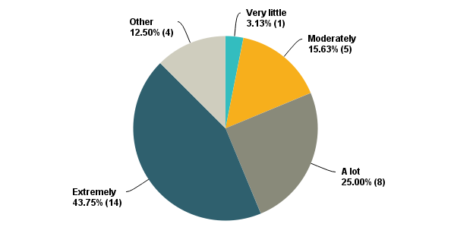
The responses to Question 10 demonstrate the significant long-term impact that student-teacher relationships have, and of the 4 respondents who selected the ‘other’ category, some were positive while expressing regret such as ‘I feel that my relationships with my teachers have definitely had a long-term impact on me, but I do wish that I had developed closer relationships with them and stayed more in touch’, while one responded with ‘negative for some, positive for others’.
Summary of survey responses
While the responses to the survey include some outlying data which deserves further investigation, the overall picture that emerges from the survey data was that a large number of respondents reported undergoing some form of religious change, and that both the learning in class and conversations with teachers outside of class were important factors in that process. In terms of my first proposition, the responses to Questions 2 & 3 appear to indicate that activities and conversations outside the classroom are more significant contributors to religious growth than learning and discussion inside the classroom. In terms of my second proposition, the overall responses to Questions 3-8 appeared to confirm that ‘of all outside of the classroom activities, informal conversations with teachers are the most significant factor that contributes to the religious change of Seminary students’. Finally, the variation of responses to Question 9 indicate that Jacobson’s claim concerning male Yeshiva students ‘who undergo religious change can identify a specific conversation as the turning point for their religious growth’ may not fully apply in this (Female) Seminary setting. While this is still a relatively small sample size, a possible reason for such differences may be due to gender differences in risk-taking and spiritual struggle (Bryant, 2007) such that women may possibly commit to religious change as a result of a spiritual journey rather than from a spiritual moment.
Interviews with Graduates
Given the responses to the survey, I adopted an open enquiry method when conducting my focused interviews (Yin, 2009, p. 106) while seeking to ask a number of questions in instances where they were not raised by the interviewee (see Appendix III). I interviewed three graduates of the Seminary.
Graduate A studied in the Seminary from September 2013 to December 2014 and our interview took place at a café. Her family are not religious, but prior to arriving at the Seminary she had been inspired to make a commitment to practice Judaism in terms of Shabbat observance, eating Kosher and dressing modestly. She explained that her objective for her time in Seminary was to learn where these laws come from and understand why she should perform them.
Graduate B studied at the Seminary from September 2014- to December 2015 and as she is currently studying in New York, our interview was conducted over the telephone. Prior to arriving at the Seminary, she had not been fully religious, and it was during this period that she committed to observe Shabbat, Kashrut, Holidays and laws of modesty.
Graduate C studied in the Seminary from September 2015 to June 2016, and as she is currently studying in Florida, our interview was conducted over the telephone. She was raised Orthodox and then became disinterested, which is why she came to the Seminary in order to reconnect with Jewish practices such as Shabbat and Kashrut.
Below is a summary of the interviews as arranged by topic.
Inside & outside the classroom
When considering the relationship between learning from teachers inside the classroom and conversations with teachers outside the classroom, Graduate A explained that ‘You can’t have the outside of the classroom without the classroom. You have to have the classroom to get those ideas flowing… and you can continue to ask your questions in the classroom. But if you really want the true deep answer, you’re going to have to take it outside, because that classroom has 15 girls in it, not just you’ (Graduate A, 15 mins). But, as Graduate A continued, the conversations outside of the classroom are not solely about getting answers. Instead, their function was ‘to make a game-plan with you and say “OK, I heard you, this is the issue and this is where you are” ...And then you figure out what your next steps are…That’s what’s so important about having guidance, having someone there to speak with. It’s not just always emotional... It’s to be able to make progress… That’s what they’re there for. I mean, they’re not just there to read a Tanach to you! They’re there to guide you as a teacher – that’s what teachers should do’ (Graduate A, 12-13 mins).
This understanding of the function of outside-the-classroom conversations was further supported by Graduate B who noted that learning is ‘put into practical terms inside class, and put into perspective outside of class’ (Graduate B, 6-7 mins), and in a similar vein, Graduate C explained that her religious change was nurtured by ‘conversations and experiences, because if you can’t like apply it to anything it’s not going to work’ (Graduate C, 10 mins).
Acknowledgement, ‘friendship’ & time
All the interviewees described how personal conversations allow for personal guidance which is crucial to religious growth. But as the interviews developed, it became clear that the individual conversations that these graduates had with their teachers while attending the Seminary were far more significant. As Graduate B observed, ‘outside of the classroom … [teachers] can acknowledge you and what you’re saying’ (Graduate B, 12 mins), explaining further that ‘being able to be acknowledged for your own individual self, and then acknowledged for the question that you’re asking, it kind of changes the relationship’ (Graduate B, 13 mins). Graduate A expressed a similar idea when stating that, ‘when you (ie. a teacher) are standing in front of a classroom for these 50 minutes you’re my teacher and you have to answer my question. But when I’m outside of the classroom, you don’t have to be there. [So] when you’re there I know that you’re really listening to me. You’re not just doing your job.’ (Graduate A, 22 mins). However, it was Graduate C who expressed this with the greatest clarity, noting that ‘I think [it’s].. not even the conversation. I mean the conversation obviously really had something and that’s really what got me to think and got me questioning certain things… but even the realization that that specific person took time to sit down and talk to me about what was going on and what I was struggling with…And just knowing that you’re a person and someone wanted to take the time to talk with you and, it’s like a friend…so it was casual and very very heartfelt, and it was not like a mandatory class. It was just like, ‘let’s talk’’ (Graduate C, 8-10 mins). Simply put, it was the fact that ‘they (ie. the teachers) care enough to sit down and talk with me about something I am going through’ (Graduate C, 10 mins).
It is noteworthy that in my survey questions I had distinguished between informal religious guidance and spending a Shabbat or Festival with a teacher (see Survey Questions 4 & 8 above). However, Graduate A made it clear that - at least from her perspective - they were very related because when a student stays with a teacher for a Shabbat or a Festival, ‘it’s an environment where the teacher focusses mainly on the girl, hears them out, no matter how long they talk for, and they work it out with them. And that’s what Shabbos is for when you’re with teachers. It’s to spend time with them’ (Graduate A, 29-30 mins).
The function of informal activities
When considering the impact of conversations as well as other outside-the-classroom activities, Graduate B explained that they were important because ‘you are missing home.. and being around someone who wanted to sit down and have dinner with you or cook with you or do any of these things reminds me of being home, which helps. You get more comfortable. And on a religious level, I don’t know if it directly plays into me becoming more religious, but I do think that it played into the environment’ (Graduate B, 9-10 mins). She explained this idea further by noting that ‘having [teachers]… around when you need them, or going to dinner or going for a walk… is something that makes it more, I guess more homey,… [and] that really helped with my growth because I wasn’t nervous to step out of my comfort zone because I knew there were people there who would be willing to discuss it, or even just sit with you, and not even talk sometimes’ (Graduate B, 21-24 mins). This too was observed by Graduate C who remarked that ‘when the teachers and their families were there [at Shabbatonim] it made it for me like so personal… I like felt that I had a support system and that I had a family’ (Graduate C, 4-5 mins), adding that this sense of home and family is compounded by the fact that some teachers are referred to by their first names, ‘like a family, or friend’ (Graduate C, 13 mins). ‘It’s like your home away from home, and that’s something that you need especially when you’re thousands and thousands of miles away and in a different time-zone from your family, so they become your family’ (Graduate C, 15 mins).

Turning-point conversations
When asked about definitive turning-point conversations, Graduate A described a time when she asked to talk to a specific teacher about a specific matter. She explained that ‘after I had that conversation, the Rabbi reassured me that we are going to figure it out and they meant it. From that conversation for the rest of the year, I had many conversations …that really allowed me to figure things out’ (Graduate A, 9-10 mins). She then added, ‘Knowing that someone is going to speak with you… is amazing. Yes, the conversation can be life-changing, but how often does that happen?’ (Graduate A, 11-12 mins). Similarly, Graduate B explained that ‘especially when you are talking about such serious topics, one conversation is not just going to be enough, and for one girl it might, but personally it was having… the dialogue …throughout the year’ (Graduate B, 33-34 mins). Graduate C did consider one event to have been a turning point. ‘I was in a class and I had this teacher and it was one of our Shabbat classes and she was talking about the beauty of Shabbat and that how, by keeping Shabbat, you are saying that Hashem created a perfect world and you don’t need to disturb it, and even… uprooting a piece of grass is …making a statement that Hashem didn’t create a perfect world. And whether or not that was metaphorical or literal, I was walking back to the dorms and I just stopped and I was like ‘I need to keep Shabbat!’. Definitely in that lesson everything combined’ (Graduate C, 1-2 mins). She continued by then adding that the conversations themselves outside of the classroom had a powerful impact on my mind-set and my actions’ (Graduate C, 16-17 mins). Yet even here, she returned to theme of the gift of time, adding that ‘there are definitely conversations with teachers that stand out with me that make you feel that… I want to spend time talking to you, having a conversation’ (Graduate C, 18 mins).
Analysis & logic linking data to propositions
Proposition 1 - Activities and conversations outside of the classroom are more significant contributors to the religious growth of Seminary students than the learning and discussion which takes place inside the classroom
The responses to question 2, along with the interview feedback clearly indicate that the learning and discussion inside the classroom is a significant factor in the nurturing of religious change. Moreover, Graduate C clearly explained how a specific class led to a significant turning point in her religious development. Notwithstanding this, the responses to Question 3 and the remarks of Graduate A & B indicate that while the learning inside the classroom lays the foundation for considering religious change, the activities and conversations outside the classroom are essential in terms of nurturing religious development.
Proposition 2: Of all outside of the classroom activities, informal conversations with teachers are the most significant factor that contributes to the religious change of Seminary students
The overall responses to Questions 3-8 appeared to confirm this proposition, and as Graduate A observed, even experiences like spending Shabbat and Festivals with a teacher are rooted in the ability to have informal conversations between teacher and student. However, what was most notable from the responses of all three interviewees was the significance they placed on the gesture of teachers giving students their own time and by doing so, ‘acknowledging’ them as their own individual selves. This gift of time and dependability of presence changed the teacher-student dynamic and created a safe and comfortable environment for religious growth which has been identified to be a crucial element in nurturing spiritual wellbeing (Cannister, 1999, p. 770). This suggests that the value of these “seemingly mundane activities” (Eisenberg, 2010, p. 81) is far less about what is said during these activities and far more about the particular student feeling that they are valued and that they matter.
Proposition 3: In keeping with Jacobson’s study which focusses solely on the male yeshiva experience, Seminary students who undergo religious change can identify a specific conversation as the turning point for their religious growth.
The variation of responses to Question 9, along with the responses of Graduates A & B suggest that Jacobson’s claim that religious change emerges from ‘Kodak Moment’ may not apply as broadly in a Seminary setting as it may do in a Yeshiva setting. Reasons for this may be due to the greater frequency of informal conversations between Seminary students and teachers. However, as suggested above, I believe it may also be due to gender differences in risk-taking and spiritual struggle.
Conclusions
I began this study with the aim of investigating the phenomenon of religious change amongst Seminary students in the real-life context (ie. the Seminary) wherein these changes occur. Basing myself on the responses received - and specifically in the context of this single Seminary – it would appear that religious growth of Seminary students occurs within students who are receptive and searching for growth and in settings and environments that support and encourage religious growth. These are settings where insightful lessons are taught by teachers who embody what they teach, and who are available and willing to speak with students outside of the classroom. Moreover, other activities that involve teachers and students are also of value - though of lesser direct impact - since they create a safe, supportive and home-like environment. It is for this reason that the campus of a Seminary can make a significant contribution to these ongoing relationships and further compound the message that such relationships can and should be fostered outside the classroom. Unlike Jacobson’s theory, not all Seminary students who underwent religious change pointed to a singular turning point conversation and this may point to differences in how male and female students make decisions in terms of their religious lifestyle, and it is noteworthy that in each instance when recalling important conversations, it seems that the time and attention given during the conversation, more than the content of the conversation, which was the significant factor. However, given the small sample of respondents and the very small number of graduates that were interviewed, these initial conclusions cannot be generalised without further exploration.

References
Berger, S.Z., Jacobson, D., Waxman, C.I., 2007. Flipping out?: Myth or fact?: The Impact of the "Year in Israel. New York: Yashar Books.
Brizel, S., 2007. Flipping Out: A review. Cross-Currents [blog], 13 December. Available at <http://www.cross-currents.com/archives/2007/12/13/flipping-out-a-review/> [Accessed
20 December 2016]

Bryant, A. N., 2007. Gender differences in spiritual development during the college years. Sex Roles, 56, 835-846. Available at < http://www.spirituality.ucla.edu/docs/academic-articles/Gender_Spirituality_SR.pdf> [Accessed 16 January 2017]

Cannister, M.W. 1999. Mentoring and the spiritual well-being of late adolescents. Adolescence 34, 769-779.

Eisenberg, S., 2010. Spiritual and Religious Mentoring: The Role of Rabbis and Teachers as Social Supporters amongst Jewish Modern Orthodox High School Graduates Spending a Year of Study in Israel. D.Ed. Azrieli Graduate School of Jewish Education and Administration Yeshiva University.

Middlesex University Ethics Committee, 2014. Middlesex University Research Ethics Review Framework. [Online] Available at: <http://unihub.mdx.ac.uk/__data/assets/word_doc/0029/156494/MU_Research_Ethical_Reviewl_Framework-June-13-2014-.docx> [Accessed 12 December 2016]

Schachter, S. Y., 2009. Review of Flipping Out? Myth or Fact: The Impact of the Year in IsraelJewish Action: The Magazine of the Orthodox Union [online], 1 June. Available at <https://www.ou.org/jewish_action/06/2009/flipping_out_myth_or_fact_the_impact_of_the_year_in_israel/> [Accessed 20 December 2016]

Tobin, D., 2003. The Post-High School Year in Israel: Parent-Child Relationships and Religious Growth. In: J. Sacks and S. Handelman, eds. 2003. Wisdom From All My Teachers. Jerusalem: Urim Publications. pp. 382-395
Unterman, Y., 2003. “If you Seek Him With All Your Heart”: Nurturing Total Individual Growth in Yeshivah. In: J. Sacks and S. Handelman, eds. 2003. Wisdom From All My Teachers. Jerusalem: Urim Publications. pp. 159-178
Yeshiva University, 2010. The Year in Israel Experience: Findings and Recommendations from an Azrielli Graduate School of Jewish Education and Administration Research Study.
Yin, R. K., 2009. Case Study Research: Design and Methods. 4th edition. London: SAGE Publications
Bibliography
Anglia Ruskin University Library, n.d. Anglia Ruskin University - Harvard system. Anglia Ruskin University Library. Available at: <http://libweb.anglia.ac.uk/referencing/harvard.htm> [Accessed 16 January 2017].

APPENDIX I
The online surveymonkey poll can be accessed via https://www.surveymonkey.com/r/7G3J5MB
APPENDIX II
Interview recordings can be accessed from http://bit.ly/2hqAuBJ
APPENDIX III
As part of my focused interviews, I sought to ask the following questions in instances where they were not raised by the interviewee
- To what extent were conversations that you had with teachers outside of the classroom connected to what they taught you inside the classroom?
- To what extent was the large open campus a factor in having conversations with teachers outside of the classroom?
- Which outside of the classroom encounters with teachers were most significant to you in terms of your religious growth?
- Were there specific conversations with teachers that you consider to be turning points in terms of your religious change?

An institution where Jewish men, generally aged 18-19, study Jewish texts and ideas
An institution where Jewish women, generally aged 18-19, study Jewish texts and ideas
While often used to refer to the Five Books of Moses, this term is used here in its broadest sense to refer to all areas of Jewish Thought and Law
The name of this teacher has been changed for the purpose of anonymity
Bible
Religious programmes that takes place over the Jewish Sabbath and involve both students and teachers

